Sometimes there is something that looks like one thing and ends up being another. Eromanga Sensei is one of those titles. On the surface it looks like your typical bother obsessed with sister stories, and that is true, but at the same time things are slightly deeper than they look on the surface.

Eromanga-Sensei revolves around Izumi Masamune, a light novel author in high school, who lives alone with his little sister Sagiri, a shut-in girl who hasn’t left her room for an entire year. Her shut in habits are so bad, she even forces her brother to make and bring her meals when she stomps the floor. Masamune wants his sister to leave her room and interact, because the two of them are each other’s only family. Masamune’s novel illustrator, pen name “Ero Manga Sensei,” draws extremely ecchi things, and is very reliable. Masamune had never met his illustrator, and figured he was just a disgusting, perverted otaku. However, the truth is revealed. His illustrator, “Ero Manga Sensei” is his own younger sister! To add to the chaos that erupts between the siblings, a beautiful, female best-selling author becomes their rival!

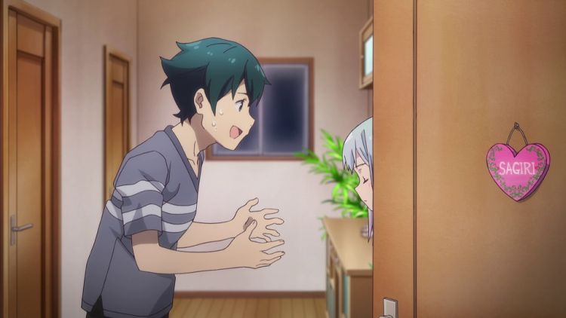

Masamune Izumi

Voiced by: Yoshitsugu Matsuoka

The protagonist of the series, he is a 15-year old first-year high school student. When he was in junior high school, he won an award for writing a light novel series. He later writes a series known as Silverwolf of Reincarnation and hires an anonymous illustrator named “Eromanga Sensei”, but discovers that Eromanga Sensei is his own stepsister Sagiri. Masamune is a teenager who lost his parents at a young age and is taking care of his hikikomori younger step-sister Sagiri. Before the story began, Masamune lost his mother and lived alone with his father. During his first year of middle school, Masamune won a light novel writing contest and eventually became a light novel author. About two years later, his father remarried another woman and he received a little sister who unbeknownst to him was also his illustrator. When his parents left for their honeymoon, they didn’t return, leaving their children orphans.   
  
Sagiri Izumi

Voiced by: Akane

Fujita The heroine of the series and the titular Eromanga Sensei, she is a 12-year-old first-year junior high school student. She is a hikikomori who never leaves her room, even to eat, instead relying on her step brother to bring food to her room. She later starts inviting her brother into her room and opens up more to the world, even venturing outside the boundaries of her room. Even though Masamune and several other people know that she is “Eromanga Sensei”, she always stalls the conversation by saying she does not know someone of that name. In the anime, Sagiri’s illustrations are drawn by Tiv.  
  
Megumi Jinno

Voiced by: Ibuki Kido

Megumi is a classmate of Sagiri, and a former amateur model. She wants to become friends with Sagiri, but is also a little perverted. Megumi is a cheerful and social girl with enough charisma to befriend many people. She seems to value friendship and tries to be helpful. She is flirtatious and has a bit of a perverted sense of humor and is confident in her looks. Masamune noted her to be positive to the point that she nearly had a positive aura and considered her a ‘Holy Attribute’. She is also perceptive, able to figure out Masamune’s feelings for Sagiri. She is also quite deceptive, seeming more innocent than she actually is and is a bit of a pervert. Overall, she seems to be a friendly girl that just wants to get along with everyone.   
  
Elf Yamada

Voiced by: Minami Takahashi

Elf is a 14-year-old popular light novel author who has sold over 2 million copies. She starts living next door to Masamune and is famed for dressing in a lolita style. She has shown to have developed romantic feelings for Masamune and has confessed to him. Elf Yamada is her pen name. Her real name is Emily Granger. Yamada Elf quit school after graduating from elementary and took up an interest in writing. She published a few novels and became the best selling author for a few weeks. Eventually, one of her novels got chosen to be an anime. At some point in time, she saw Eromanga’s art and wanted Eromanga to become her illustrator.

Muramasa Senju

Voiced by: Saori Ōnishi

Muramasa is a successful light novel writer who has sold over 14.5 million copies of her novel series. She is a fan of Masamune’s “Silverwolf of Reincarnation” series, So she gets upset after he ends series. She tried to stop him from writing romantic comedy series but admitted defeat after losing to him in Tenkaichi-Budoukai competition. She is in love with Masamune, but he rejects her after she confesses her feelings to him. Muramasa Senju is her pen name. Her real name is Hana Umezono

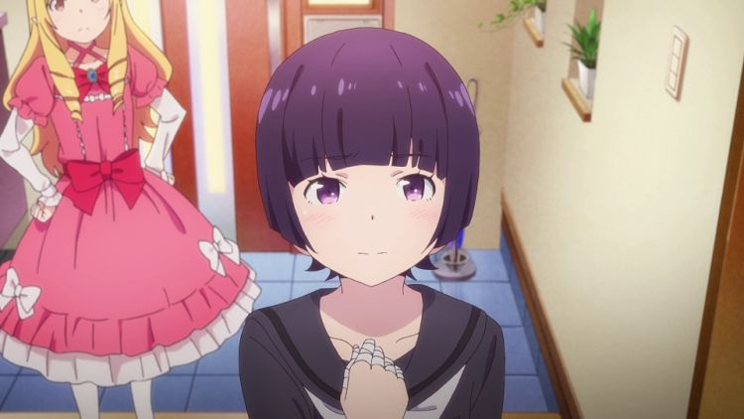Eromanga Sensei is one of those weird anime shows where you go to judge the book by the cover, but find that there is something a little deeper to things than there seems to be. On the surface, Eromanga Sensei looks like one of those weird loli or sister-love anime shows where the older brother has an obsession with his younger sister; while this is true on the surface, beyond that it is more about a girl who while having a very weird hobby (drawing Ero or “dirty” books) and an obsession with the body’s sexual organs…. But more so a story about a shut in and the attempts of the people who slowly become her friends or friend-enemy and help her rejoin the world. When viewed from this aspect, things don’t seem so bad to deal with. Eromanga Sensei got a bit of a bad rap due to being viewed in the former mindset of loli lust than the latter about a shut in who rejoins the world.

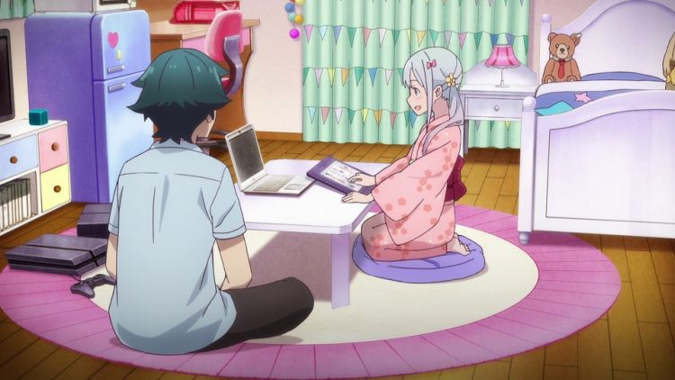

To be honest, the characters are the biggest drawback to Eromanga Sensei. Some of the characters, like Elf Yamada especially, are more interesting than Izumi siblings. After watching things like Bakuman, which have a much greater and more realistic take on the whole manga or light novel writing worlds, watching Eromanga Sensei is like watching some weird bizzaro world. The Izumi siblings both are well known under their specific pen names but do not have any pressure from a publisher or anything else. But then again, that’s not the focus of Eromanga Sensei. Back to the characters, I think that Sagiri as a main is just too plain and boring outside of her obsession, and her brother Masamune is just too normal. This leaves the real entertainment on the B and C level characters to carry the show. Not something you want to see in any anime.

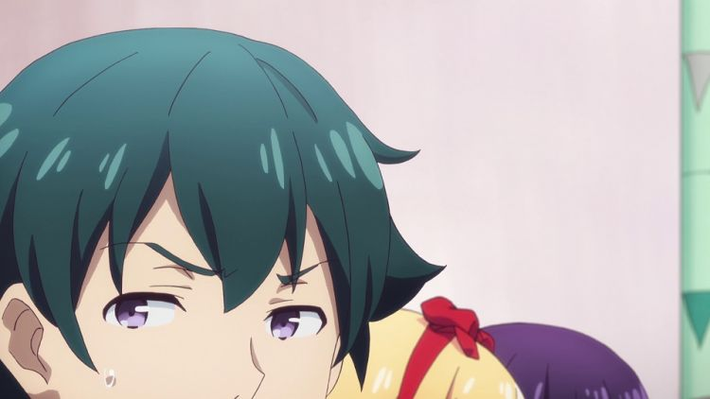

Overall, Eromanga Sensei is a good little gateway anime if you want to take a chance and walk on the weird side of obsessions with a hint of a deeper story. While the mains are pretty boring, the side characters are more than entertaining enough to make up for it.